**SOFTWARE ENGINEERING**

**(IT-314)**

**EVENT PLANNER APPLICATION**

High Level Design Document

Version 1.0

**Team no: 14**

**Instructor: Prof. Asim Banerjee**

**Team Mentor: K Hemantha**

**Date: 31 March, 2016**

**Team Members**

|  |  |  |
| --- | --- | --- |
| **S.No** | **Name** | **ID** |
| 1. | Patel Yash | 201301008 |
| 2. | Patel Tej Naginbhai | 201301018 |
| 3. | Anavadiya Yash Kumar | 201301052 |
| 4. | Chauhan Dwimitra Dharmendra | 201301079 |
| 5. | Rahul Shashank Saranjame (Team Leader) | 201301101 |
| 6. | Fatnani Varun Kumarbhai | 201301152 |
| 7. | Nikita Jain | 201301155 |
| 8. | Karri Kiran Satish Reddy | 201301168 |
| 9. | Raman Kumar Douchaniya | 201301202 |

**Version History**

|  |  |  |
| --- | --- | --- |
| **Date** | **Version no.** | **Authors** |
| 31/03/2016 | 1.0 | Kiran Reddy |

**Introduction**

The purpose of this High Level Document(HLD) document is to add the necessary detail to the current project description to represent a suitable model for coding.This document is also intended to help detect contradictions prior to coding and can be used as a reference manual for how the modules interact at a high level.

**Scope**

The High Level Document (HLD) documentation presents the structure of the system,such as the database architecture.The HLD uses non-technical to half technical terms which should be understandable to the administrators of the system.

**Overview :**

The overview of the High Level Design will :

* Present all of the design aspects and define them in detail.
* Describe the user interface being implemented.
* Describe the hardware and software interfaces.
* Describe the performance requirements.
* Include design features and the architecture of the project.
* List of some of the non-functional attributes are
  + Security
  + Reliability
  + Maintainability
  + Reusability
  + Performance

**Security** : The security is the major issue with respect to the private organisations we are issuing a unique username and password and if forgot his password we are sending a one time password for his registered email.This ensures security.

**Reliability** : A local database will be implemented in which all computers are connected to the same network.Since no one will interrupt this server there is no disturbance this ensured reliability of the software.

**Maintainability :**Since this is a web application very less maintenance is required and since they are all connected to the same server that is local host it is very easy to update when a new update

Comes.

**Reusability :**The code written and the components used should have the ability to be reused with no problems.Code must be written with well specified comments so that who uses the code later on can easily get the content.Everything is completely reusable to anyone.

**Performance** : Performance is very important for this project.The updation,deletion and modification to the database must be very fast so that it does not affect the performance of the project.

**Design Details :**

**Main Design Features :**

The main design features include five major parts : the architecture,the user interface design,external interface,the database,process relation and automation.In order to make these designs easir=er to understand,the design has been illustrated in below diagrams.

**ER Diagram:**

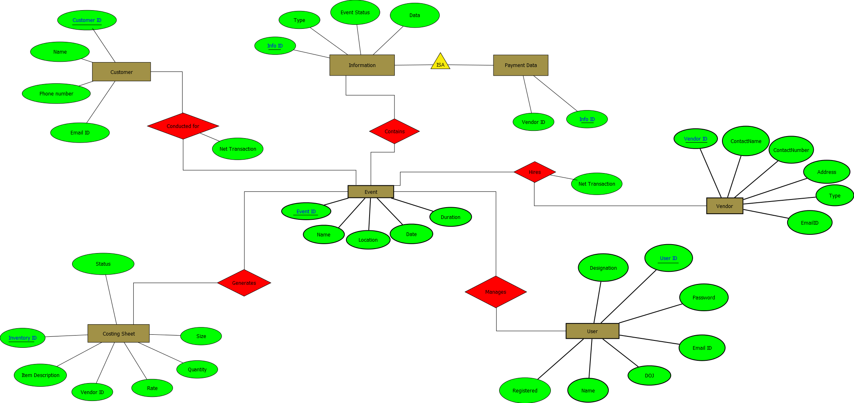

**Use Case Diagrams:**

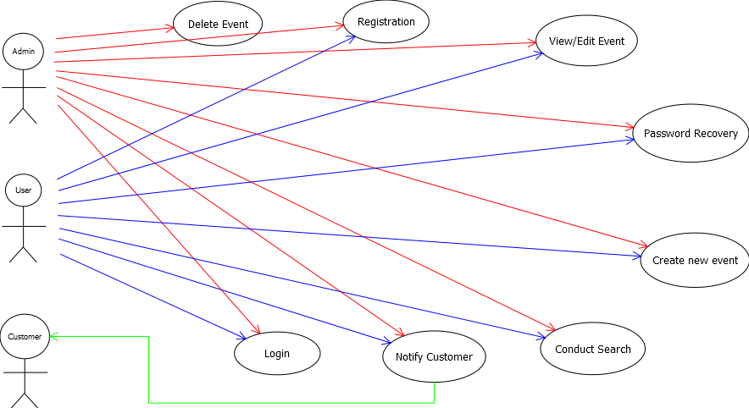

**System Components :**

**Database Tables :**

**Event_ID table :**

|  |  |  |  |
| --- | --- | --- | --- |
| **Name** | **Type** | **Nullable** | **Unique** |
| Event_ID | varchar | No | Yes(Primary Key) |
| Name of the event | varchar | No | No |
| Location of the event | varchar | No | No |
| Date of the event | time | No | No |
| Duration of the event | Int | No | No |

**Costing_Sheet table**

|  |  |  |  |
| --- | --- | --- | --- |
| **Name** | **Type** | **Nullable** | **Unique** |
| Inventory_ID | varchar | No | Yes(Primary Key) |
| Vendor_ID | varchar | No | Yes(Primary Key) |
| path_description | varchar | No | Yes |
| Size | int | No | No |
| Quantity | int | No | No |
| status | varchar | No | No |

**Customer Table :**

|  |  |  |  |
| --- | --- | --- | --- |
| **Name** | **Type** | **Nullable** | **Unique** |
| Customer_ID | varchar | No | Yes(Primary Key) |
| Name | varchar | No | No |
| phone_number | varchar | No | No |
| email | varchar | No | No |

**Module Description** :

**Login Module** :

The login module helps the user to login into site and access all the functionalities of the website.If he enters wrong credentials he will be prompted with wrong username or password.

**Registration :**

The user will be given a username and password by the organisation he enters the credentials where he will be redirected to registration page.If he enters wrong credentials he will be in the same page.

**Forgot Password :**

An email consisting of new random password will be sent to the registered email thereby he can re login to the site.

**Event Search :**

A User can search a particular event based on the event name,location,date,budget and event date.

**Email-Notification :**

An email can be sent to the customer regarding the changes they are going to be done for a particular event apart from the customer requirements.If he approves this then only organisation will continue with the change.

**Create/ Delete/ Modify Event :**

An user can create an event at any time and he modify the existing event at any time the power for deletion a particular event lies with the admin only.As a part of creating an event he will also generate costing sheet for the event.